

**CHAPTER 1**

**INTRODUCTION**

* 1. **Introduction**

Nowadays, technology is an integral part of everyone's lives. It influences several facets of everyday life and allows improved social synergy, easy transportation, the capability of indulging in entertainment and media and helps in the advancement in medicine. The invention of several devices like cell phones and computers has made several people reliant on technology for interacting with friends, store and retrieve information like images, videos, documents, and music. The world wide web is a common interface that several devices use in order to make the daily life of many people. Internet has played a pioneering role in providing immediate solutions for various problems and has given the ability and has connected all the remote places which has contributed to significant reduction in cost and also energy consumption. Home automation or intelligent home is defined as initiation of technology inside the home surroundings to provide ease and safety to its inhabitants.

The technology of the Internet of Things is used to examine and execute home automation. GPRS, GSM, Bluetooth, Wi-Fi and cellular networks support remote data transferring and are used to enter abundant levels of acumen within the home. Home automation has the ability to greatly assist and improve the quality of life of older people. IoT also greatly contributes to supply management and observance with ease of control. The World wide web is greatly used in home automation that gives decisions via conservative use of energy. The user can remotely control the gate, home appliances, etc comfortably and conveniently anywhere and anytime. Technology has improved a lot in over the last few decades. One of the best and biggest technological advancement is the creation of “Smart Phones”. Smart devices make life of a person easy and updated.

* + 1. **Technology**

1. The Internet of things (IoT) is known as connecting objects like cell phones, personal computer and other devices to the world wide web, which introduces a new era in the area of communication, where objects communicate with each other without human intervention. The establishment of IoT has led to increased research in the area of IoT and development of home automation is becoming really famous nowadays. Most of the equipments and gadgets are controlled and monitored to help and assist humans. Moreover, various wireless technologies assist in communicating with remote places which play a great role in the intelligence of house surroundings. IoT is a sophisticated network of nodes with the unique ability of exchanging data and knowledge wirelessly which enables communication between two objects thereby making them smart and removing the need of humans for machine to machine communication.

**1.1.2 Implementation**

IOT is generally considered as “Infrastructure of information Society”, it enables us to obtain the data by each and every type of mediums like animals, kitchen appliances, humans, vehicles. Without human intervention IOT connects the physical objects that can exchange and communicate information between them. In the modern era, security and surveillance are important issues. Recent acts of theft/terrorism have highlighted the urgent need for efficient video surveillance and on-the-spot notification of ongoing thefts to house owners and other household members. This project is concentrates primarily on the security aspects by listing the typical security challenges in IOT systems in general and summing these challenges up to develop a functional and secure product from scratch. A microcontroller is chosen for this project and a test environment is built to experiment and develop the security breaches. Architectural designs are chosen for the API being developed and even for the Android Application. A detailed description is made of the multi-master database represented by Azure active directory and its importance to achieving the security of an essential security breach.

**1.2 Objective**

* Constructing an architecture regarding the security and functionality.
* Establishing a reliable technique to determine if a user is in the physical proximity of the door lock using WiFi.
* Attaining a proper policy to authenticate users trying to access the door.
* Creating an android application that can serve as the user endpoint.

**1.3 Problem Definition**

In the modern era, security and surveillance are important issues. Recent acts of theft/terrorism have highlighted the urgent need for efficient video surveillance and on-the-spot notification of ongoing thefts to house owners and other household members. A number of surveillance solutions are currently available on the market, such as CCTV cameras and digital video recorders (DVRs) that can record the unauthorized activities of a trespasser, but cannot distinguish between human and non-human objects. In recent times, the ratio of theft has increased tremendously due to a lack of awareness and low availability of smart-gadgets. The task of face detection and the recognition of an intruder become very difficult when the intruder hides their face partially or fully using some type of material, such as plastic, leather, or fabric. Legacy systems cannot provide real-time theft notification to the house owner nor detect partially or fully obscured faces. It is also challenging for old systems to detect the intruder in the dark using a CCTV camera without night vision capability. The major flaw with this kind of arrangement is that it demands the 24/7 availability of a house owner or member, or manual video surveillance, which is almost impossible. In addition, it is a tedious task to go through all the recorded video clips after a possible theft has become known. It might be that the storage server contains a large amount of family member footage, which is of no use in identifying trespassers.

**CHAPTER 2**

**LITERATURE SURVEY**

**2.1 Literature Summery**

Purchasing of medicines online is recently started so there is only little literature available. Less research papers are available on online medicines/medical products shopping. Some research papers are available showing benefits of selling medicines and medical products online. With expanded utilization of the web, more individuals access medications and health supplements on the web. However, little is thought about components connected with utilizing internet purchasing.

**2.1.1 Literature Survey**

1. [Pèter Szabó](https://ieeexplore.ieee.org/author/37086886146) et al. [1] Unsupervised machine learning became a ubiquitous method appearing in E-commerce solutions that strive to provide personalized recommendations for their users. Most of those solutions embrace collaborative filtering (CF) to predict conversions, which are the beneficial user events, such as a purchase. Traditionally, the predictions were made based on rating data. However, e-commerce users seldom leave ratings. Instead, we must rely on user events, such as viewing an item or adding it to the cart. The event-based approach seems counter-intuitive, for the reason that the operation time of recommender systems increases exponentially with the increase of data-points.One of the main contributions of this paper is the UX value function. It reduces all events between an item and a user to a single user experience number, which also depends on the sequentiality of the events. We present a method to calculate this number in linear time. Then we use a deep neural network to predict the likelihood of conversions based on this number to prove the practical solvability of the problem in a scalable manner, with a relatively fast learning speed and good prediction accuracy. We have conducted an extensive experimental analysis on Kechinov’s ‘eCommerce Events History in Cosmetics Shop’ dataset, containing 8,738,120 user events. The results of those experiments prove the efficiency and applicability of the developed approach.

2. [Elizabeth Jordan](https://ieeexplore.ieee.org/author/37088975819) et al. [3] This paper presents an overview of some key results from a body of optimization studies that are specifically related to COVID-19, as reported in the literature during 2020-2021. As shown in this paper, optimization studies in the context of COVID-19 have been used for many aspects of the pandemic. From these studies, it is observed that since COVID-19 is a multifaceted problem, it cannot be studied from a single perspective or framework, and neither can the related optimization models. Four new and different frameworks are proposed that capture the essence of analyzing COVID-19 (or any pandemic for that matter) and the relevant optimization models. These are: (i) microscale vs. macroscale perspective; (ii) early stages vs. later stages perspective; (iii) aspects with direct vs. indirect relationship to COVID-19; and (iv) compartmentalized perspective. To limit the scope of the review, only optimization studies related to the prediction and control of COVID-19 are considered (public health focused), and which utilize formal optimization techniques or machine learning approaches. In this context and to the best of our knowledge, this survey paper is the first in the literature with a focus on the prediction and control related optimization studies. These studies include optimization of screening testing strategies, prediction, prevention and control, resource management, vaccination prioritization, and decision support tools. Upon reviewing the literature, this paper identifies current gaps and major challenges that hinder the closure of these gaps and provides some insights into future research directions.

3. [Liu Xiaojing](https://ieeexplore.ieee.org/author/37530114500) et al. [2] The mode of economic growth is first put forward by Soviet economists in the early 1960s, because of the impact of the new technology revolution and development adjusting strategy of other countries, the Soviet Union put forward the intensive production policy, and this policy required the social production mode to change from extensive type to intensive type, and to make great achievements with less cost. As the understanding of growth mode deepened, China is abandoning the extensive economy growth mode, which only pursues quantity and speed, and now, China is exploring way to intensive economy growth mode. This paper showed the characteristics of e-commerce in China, analyzed the impact mechanism of e-commerce to the changing of economic growth mode, proposed suggestions for the influence of e-commerce.

4. A.H.M. van Limburg et al.[4] Modern day healthcare is offering more and more treatment alternatives on the Internet, so-called eHealth. In order to reform the business logic of these organizations from the traditional healthcare services towards more eHealth in their services, an implementation strategy is needed to guide this reformation. A currently popular approach to guide these reformations and to come to an eventual implementation is by the use of business models. This paper describes what business models are and what their potential for designing and implementing eHealth applications can be. Also, three recent methods of business modeling that aimed to create sustainable eHealth applications will be described as an example, followed by some potential complications and their corresponding challenges that can appear when working on a business model for innovative eHealth applications.

**CHAPTER 3**

**SCOPE OF PROJECT**

**3.1 Existing System**

* The growth of online pharmacies due to the following reasons:
* Pharmacies are the first points of access to medicines for consumers. However, in India, urban areas have higher density of pharmacies than rural areas.
* Due to the nuclear family system, the elderly have reduced access to medicine. People In remote areas need to travel long distances to acquire medicines.
* Retails stores may be short of required stock or specific brands and consumers may need to visit multiple stores for procuring specific medicines.
* Patients suffering from chronic conditions like diabetes, hypertension, etc. need regular medication in which case medicine refilling becomes an issue and leads to noncompliance.
* Changing lifestyle – Goods are being increasingly ordered online.
* Rising burden of diseases – there has been a shift from acute to chronic illnesses both in rural and urban India.
* Online pharmacies offer multiple options at varied prices.
* Easy availability of medicines to the rural and remote parts of the country.
* Online pharmacies can bridge this gap by providing easy and affordable access to medicines
* Improves awareness regarding medicines amongst common man.
* Rare medications can be acquired with more ease as online pharmacies can access an inventory of multiple stores at a time and aggregate supplies. In all the above cases, online pharmacies can be of immense value by improving accessibility of medicines and thus empowering the consumer.

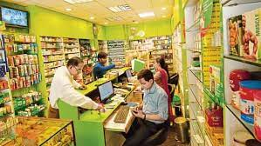

**Fig 3.1: Existing pharmaceutical system**

**3.2 Proposed System**

An online medicine delivery system is an online based web application that operates over the Internet and sends orders to customers through credit cards, shipping companies, or pay on delivery system. People can buy and sell their products sitting at home. It is getting popular day by day all over the world even in domestic market space. The aim is to make the ordering process and delivery systems of medicines much easier and customer-friendly. It’s very important to make a user-friendly environment.

This section describes the basic structure of the proposed system.  The block diagram of the proposed system. In this section we proposed the system design. The system will provide the necessary features that our system entails. Block diagram illustrates that customers can see the web application and do the registration with proper information to the website. After completing registration to the website customer can view the products, make purchase by adding to cart. Customers can pay at the time of delivery which is called cash on Delivery (COD). Customers feel more comfortable by doing COD payment because it is more reliable.

**3.2.1 Features of project**

1. **Prescription Requirement:** One thing that is awesome about online medicines seller that they ask about prescription while someone buy medicine from their websites.
2. **Online Advertising:** Online advertisement also gives benefits to the seller as advertisements on seller’s website or mobile application will provide extra money to the seller. Internet promoting is may be the most recognizable case of how firms utilize the rich information.
3. **Easy Return Policy:** If medicines are not required by the buyer then it can be returned to the seller by means of courier. Buyer has to register for a return of parcel on web. Seller will inform to the courier service to pick up the parcel from buyer (not broken strips) and the cash will be credited to the buyers account shortly once the parcel is received to the seller.
4. **Save Time:** One of the most precious resource time can be save by online order of medicines as it may not be possible that all medicines may available in a single medical shop.
5. **Save Money:** As order of medicines is online there will be no need to go to the medical shop and waste money. Also some websites provides discount coupons that can be used while buying medicines and other medical products. Coupons will give extra discounts as per the offer offered by the seller or any other co-partner of the firm. Sometimes it gives more than 20 percent discount on bill amount. Save Fuel As buyers do not need to go to market or any other place to buy medicines, so fuel will be saved. Sometimes one medicine may not be available in the market but buyers need it on urgent basis so he has to go to each and every shop to check the availability of that medicine. And when it will be delivered by the seller the courier boy delivers all nearby parcels in the same time so it also saves time and fuel.
6. **Web Application:** Web applications are available which makes online shopping of medicines more convenient and easier.

**3.3 System Architecture**

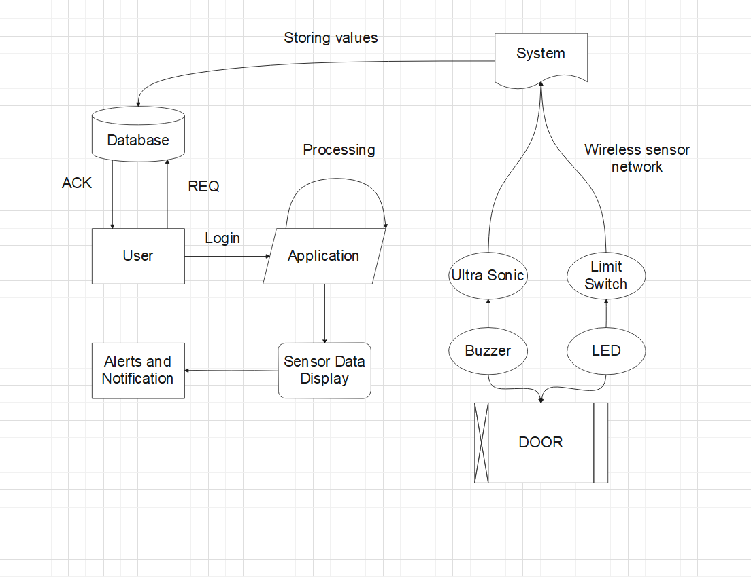

**Fig 3.2: Architecture Diagram**

* 1. **Project Function**

1. **Login Page:** The user can login with a valid username and password that has been registered under the supervision of the admin.
2. **Sign-Up Page:** The signup page of the developed system. It has illustrated that the user can sign up valid username and password.
3. **Controlling:** User can control appliances like fan, light by using blynk application.
4. **Monitoring:** If any unwanted condition of door open take place then notification will be display on Blynk application.

**CHAPTER 4**

**PERFORMANCE REQUIREMENTS**

**4.1 Hardware Requirement**

1. Processor - Pentium IV/Intel I3 core

2. Speed - 1.1 GHZ

3. RAM - 512 MB(min)

4. Hard disk - 20 GB

5. Keyboard - Standard Keyboard

6. Mouse - Two Or Three Button Mouse

7. Monitor - LED Monitor

* 1. **Software Requirement**

**4.2.1 Xamp**



**Fig 4.1: XAMPP**

XAMPP is one of the widely used cross-platform web servers, which helps developers to create and test their programs on a local webserver. It was developed by the Apache Friends, and its native source code can be revised or modified by the audience. It consists of Apache HTTP Server, MariaDB, and interpreter for the different programming languages like PHP and Perl. It is available in 11 languages and supported by different platforms such as the IA-32 package of Windows & x64 package of macOS and Linux.

XAMPP helps a local host or server to test its website and clients via computers and laptops before releasing it to the main server. It is a platform that furnishes a suitable environment to test and verify the working of projects based on Apache, Perl, MySQL database, and PHP through the system of the host itself. Among these technologies, Perl is a programming language used for web development, PHP is a backend scripting language, and MariaDB is the most vividly used database developed by MySQL.

* + 1. **Javascript**

JavaScript is a lightweight, interpreted programming language. It is designed for creating network-centric applications. It is complementary to and integrated with Java. JavaScript is very easy to implement because it is integrated with HTML. It is open and cross-platform. Javascript is the most popular programming language in the world and that makes it a programmer’s great choice. Once you learn Javascript, it helps you develop great front-end as well as back-end software using different Javascript-based works like Query, Node. JS etc.

**4.2.3 The list of software requirement is as follow:**

1. Operating System: Windows XP and later versions
2. Front End: HTML, CSS
3. Programming Language: PHP
4. Tool: XAMP & NOTEPAD ++
5. Domain: WEB APPLICATION
6. Algorithm: Hashing.

**CHAPTER 5**

**FEASIBILITY STUDY**

**5.1 Functional Requirements**

**5.1.1 System Feature**

* Functional Requirements are the statements of services the system should provide and how the system reacts to particular inputs and how the system should behave in particular situation.
* A specification constraining the way in which a given task is to be performed, the results to be obtained (speed, accuracy, etc.) as well as the elements of the functional entities involved (initiator, source, receptor, etc.).
* The requirement specifies that a function that a system or component must be able to perform. These include inputs, outputs.
* Functional requirements are also called behavioral requirements because they address what the system does.

**5.1.2 System interface**

* These should be quality of image.
* Database requirement.
* Required software should be properly installed.

**5.2 External Interface Requirements**

**5.2.1 User Interface**

The user has to interface with the system to access the features and to provide easy communication the with system.

**5.2.2 Hardware Interface**

The computer system is used to control the system.

**5.2.3 Software Interface**

The web browser is used to interface with the web application.

**5.2.4 Communication Interface**

There is a specific network protocol as long as the performance requirement are satisfied.

**5.3 User Interfaces**

The user experience should be considered as priority in user interface. This is the way that the product will be used by users. Users should meet the exact needs they want, without confuse. Designer should clear the primary objective of developing an interactive product. It is suggested to classify the objectives in terms of usability and user experience goals. There are six goals of usability. They could make the product easy to learn and effective to use.

**5.3.1 Six Usability Goals**

* Effective to use(effectiveness)
* Efficient to use(efficiency)
* Safe to use(safety)
* Having good utility(utility)
* Easy to learn(learnability)
* Easy to remember how to use(memorability)

Effectiveness is a common goal to reach the best result of the expectation. The performance of the software is satisfactory. Efficiency is focus on the cost of computation of the software. Most users make an attention on the speed of software, they think every action should be fluent. If a lag accrued during the operation, people will think there are some problems with it. It will worsen the user experience.

* 1. **Nonfunctional Requirements**

**5.4.1 Usability:**

The ease with which the system can be learned, managed or used. Usability gives the measure of how much user friendly the system is.

**5.4.2 Reliability:**

The degree to which the system must work for users. It also refers to the mean time between failures, means what can be the maximum down time.

**5.4.3 Performance:**

Performance specifications typically refer to response time, transaction throughput, and capacity. They deal with response time, which means the time taken by the system to load, reload, screen open and refresh times etc.

**5.4.4 Scalability:**

It refers to the ability of the proposed software application to increase the number of users or applications associated with the product.

**5.4.5 Open standard:**

It ensures the viability and future expansion of the system, all offered development tools, server software, as well as, the application is based on open templates and are available under the terms of the General Public License.

**5.5 Analysis Models: SDLC Model to be applied**

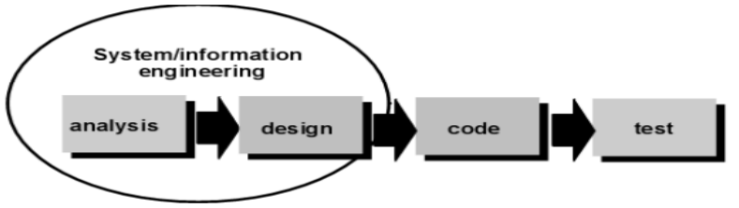

**Fig 5.1: SDLC Model**

**5.5.1 Requirement Analysis and Definition:**

At this stage the system features, constraints and objectives are determined through consultation with system users. All of these will be specified in detail and function as system specifications. The way to do this is to collect the complete requirements and then analyze and define the needs that must be met by the program to be built. This phase must be done in full to be able to produce an accurate design.

**5.5.2 System and Software Design:**

In the System and Software Design Phase, a system architecture will be formed based on established requirements. in addition, identification and depiction of the basic abstraction of the software system and its relationships are carried out. The design is done after the complete requirements are collected in full.

**5.5.3 Implementation and Unit Testing:**

In this Implementation and Unit Testing phase, the results of the software design will be realized as a set of programs or program units. Program design is translated into codes using predetermined programming languages. The program built by each unit will be tested if it meets the specifications.

**5.5.4 Integration and System Testing:**

In this Integration and System Testing phase, each program unit will be integrated with each other and tested as a whole system to ensure that the system meets existing requirements.

**5.5.5 Operation and Maintenance:**

In this Operation and Maintenance stage, the system is installed and put into use. It also corrects errors that are not found at the manufacturing stage. In this stage, system development is also carried out such as the addition of new features and functions.

**CHAPTER 6**

**SYSTEM DESIGN**

**6.1 Data Flow Diagrams**

A data flow diagram (DFD) is a graphical or visual representation using a standardized set of symbols and notations to describe a business's operations through data movement. They are often elements of a formal methodology such as Structured Systems Analysis and Design Methods.

The objective of a DFD is to show the scope and boundaries of a system as a whole. It may be used as a communication tool between a system analyst and any person who plays a part in the order that acts as a starting point for redesigning a system. The DFD is also called as a data flow graph or bubble chart.

DFD 0, also called context diagram of the result management system. As the bubbles are decomposed into less and less abstract bubbles, the corresponding data flow may also be needed to be decomposed.

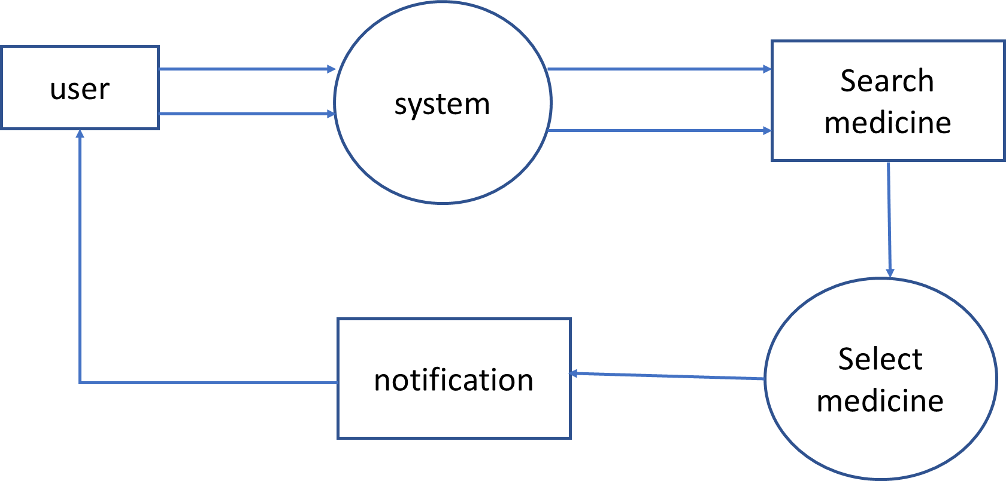

**Fig 6.1: DFD0 Diagram**

DFD 1, a context diagram is decomposed into multiple bubbles/processes. In this level, we highlight the main objectives of the system and breakdown the high-level process of 0-level DFD into subprocesses.

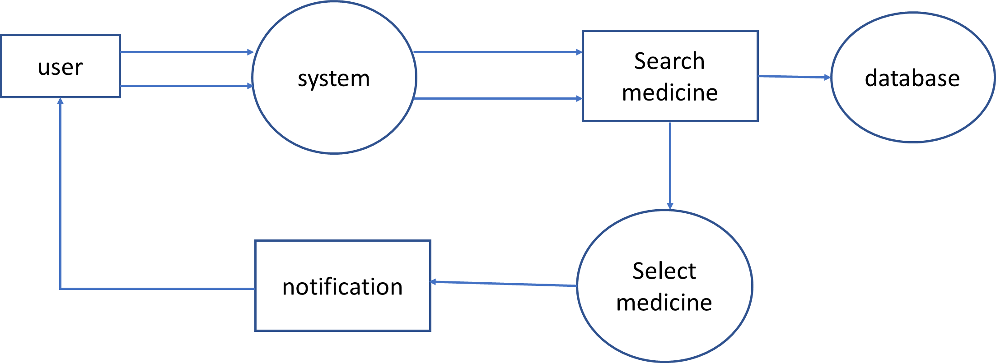

**Fig 6.2: DFD 1 Diagram**

DFD 2 goes one process deeper into parts of 1-level DFD. It can be used to project or record the specific/necessary detail about the system's functioning.

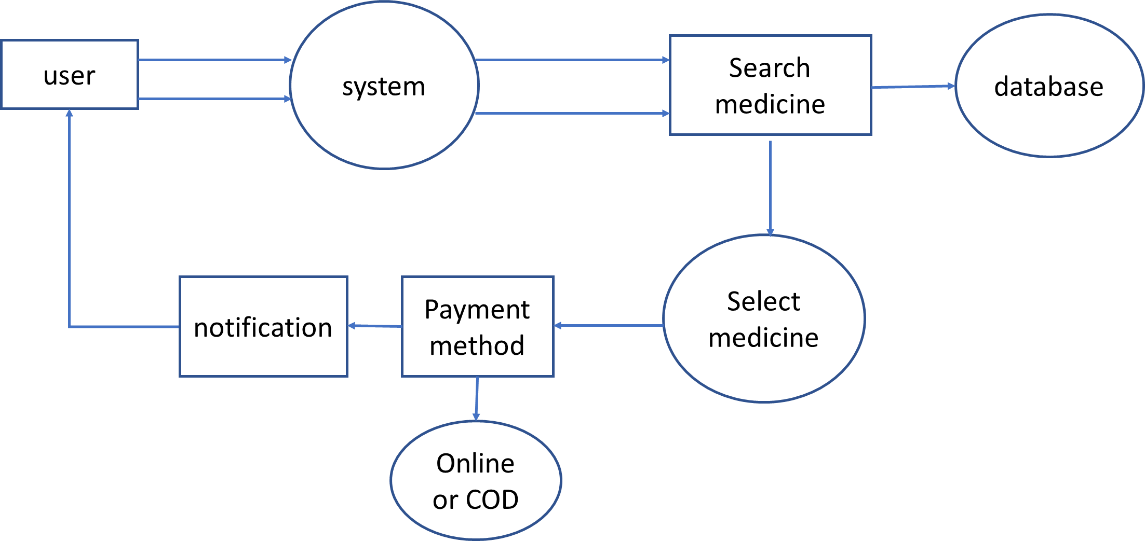

**Fig 6.3: DFD2 Diagram**

**6.2 ER Diagram**

An entity relationship diagram (ERD), also known as an entity relationship model, is a graphical representation that depicts relationships among people, objects, places, concepts or events within an information technology (IT) system. Depending on the scale of change, it can be risky to alter a database structure directly in a DBMS. To avoid ruining the data in a production database, it is important to plan out the changes carefully. ERD is a tool that helps. By drawing ER diagrams to visualize database design ideas, you have a chance to identify the mistakes and design flaws, and to make corrections before executing the changes in the database.

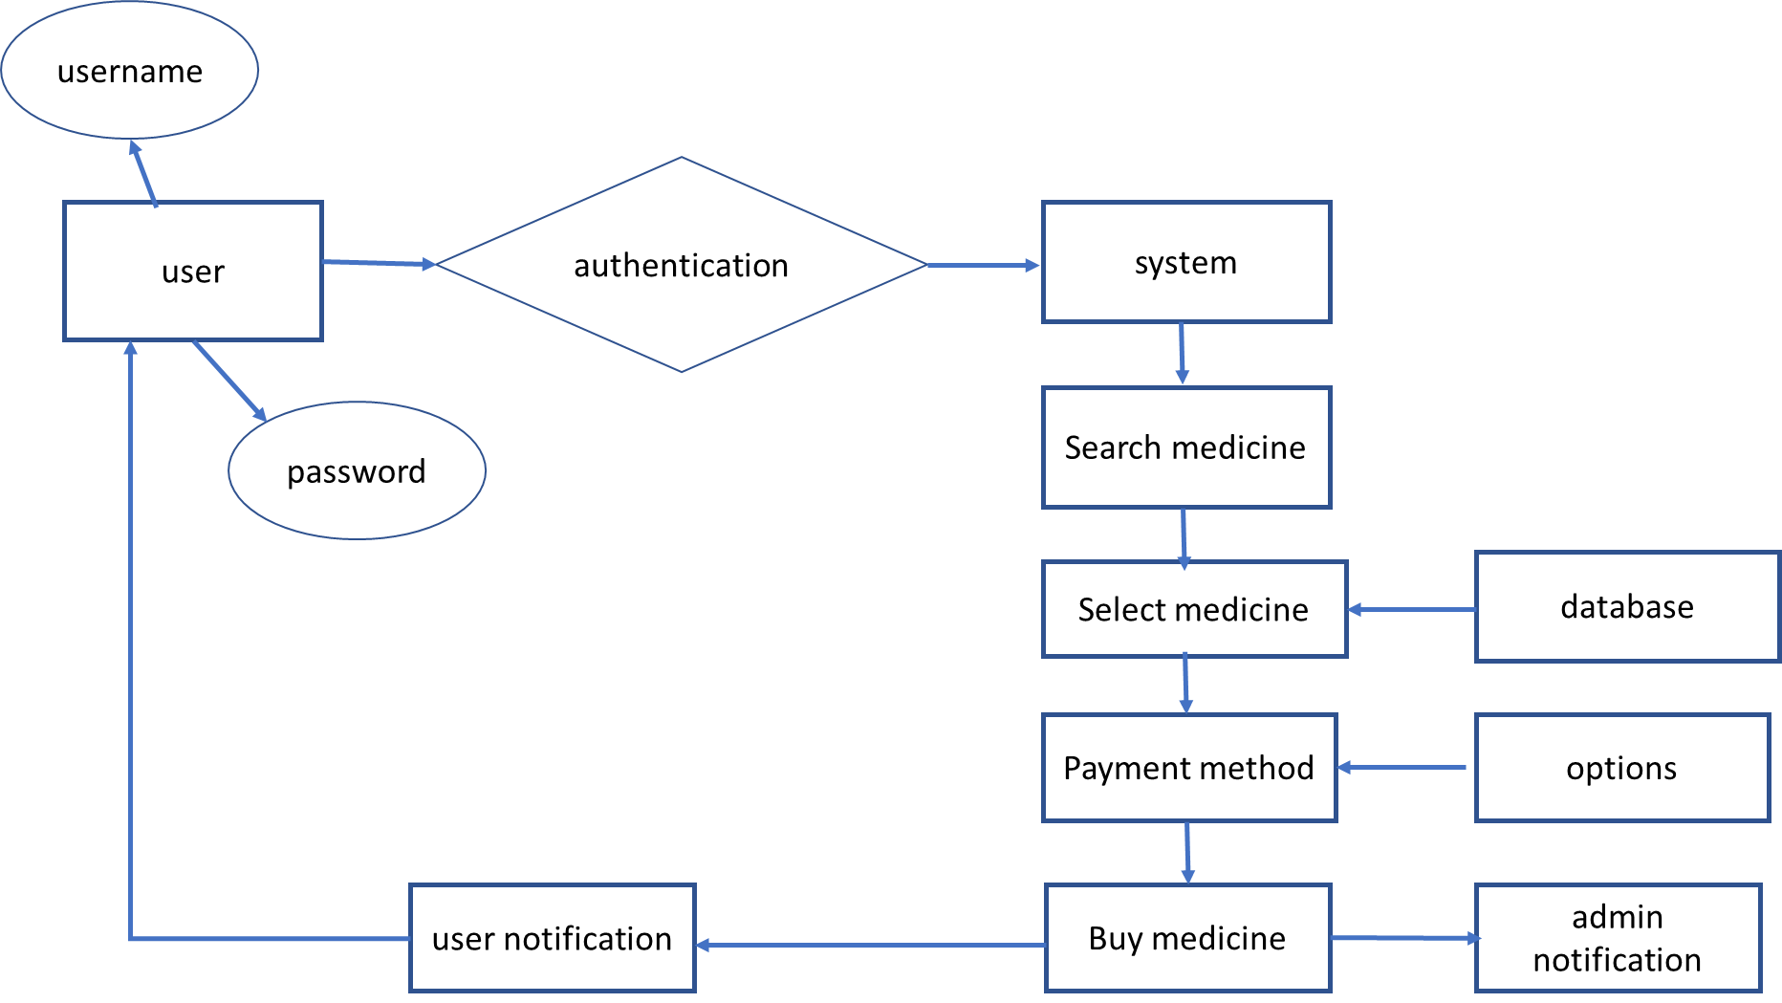

**Fig 6.4: ER Diagram**

**6.3 UML Diagram**

**6.3.1 Activity diagram**

Use cases show what your system should do. Activity diagrams allow you to specify how your system will accomplish its goals. Activity diagrams show high-level actions chained together to represent a process occurring in your system. An activity diagram is essentially a flowchart, showing flow of control from activity to activity

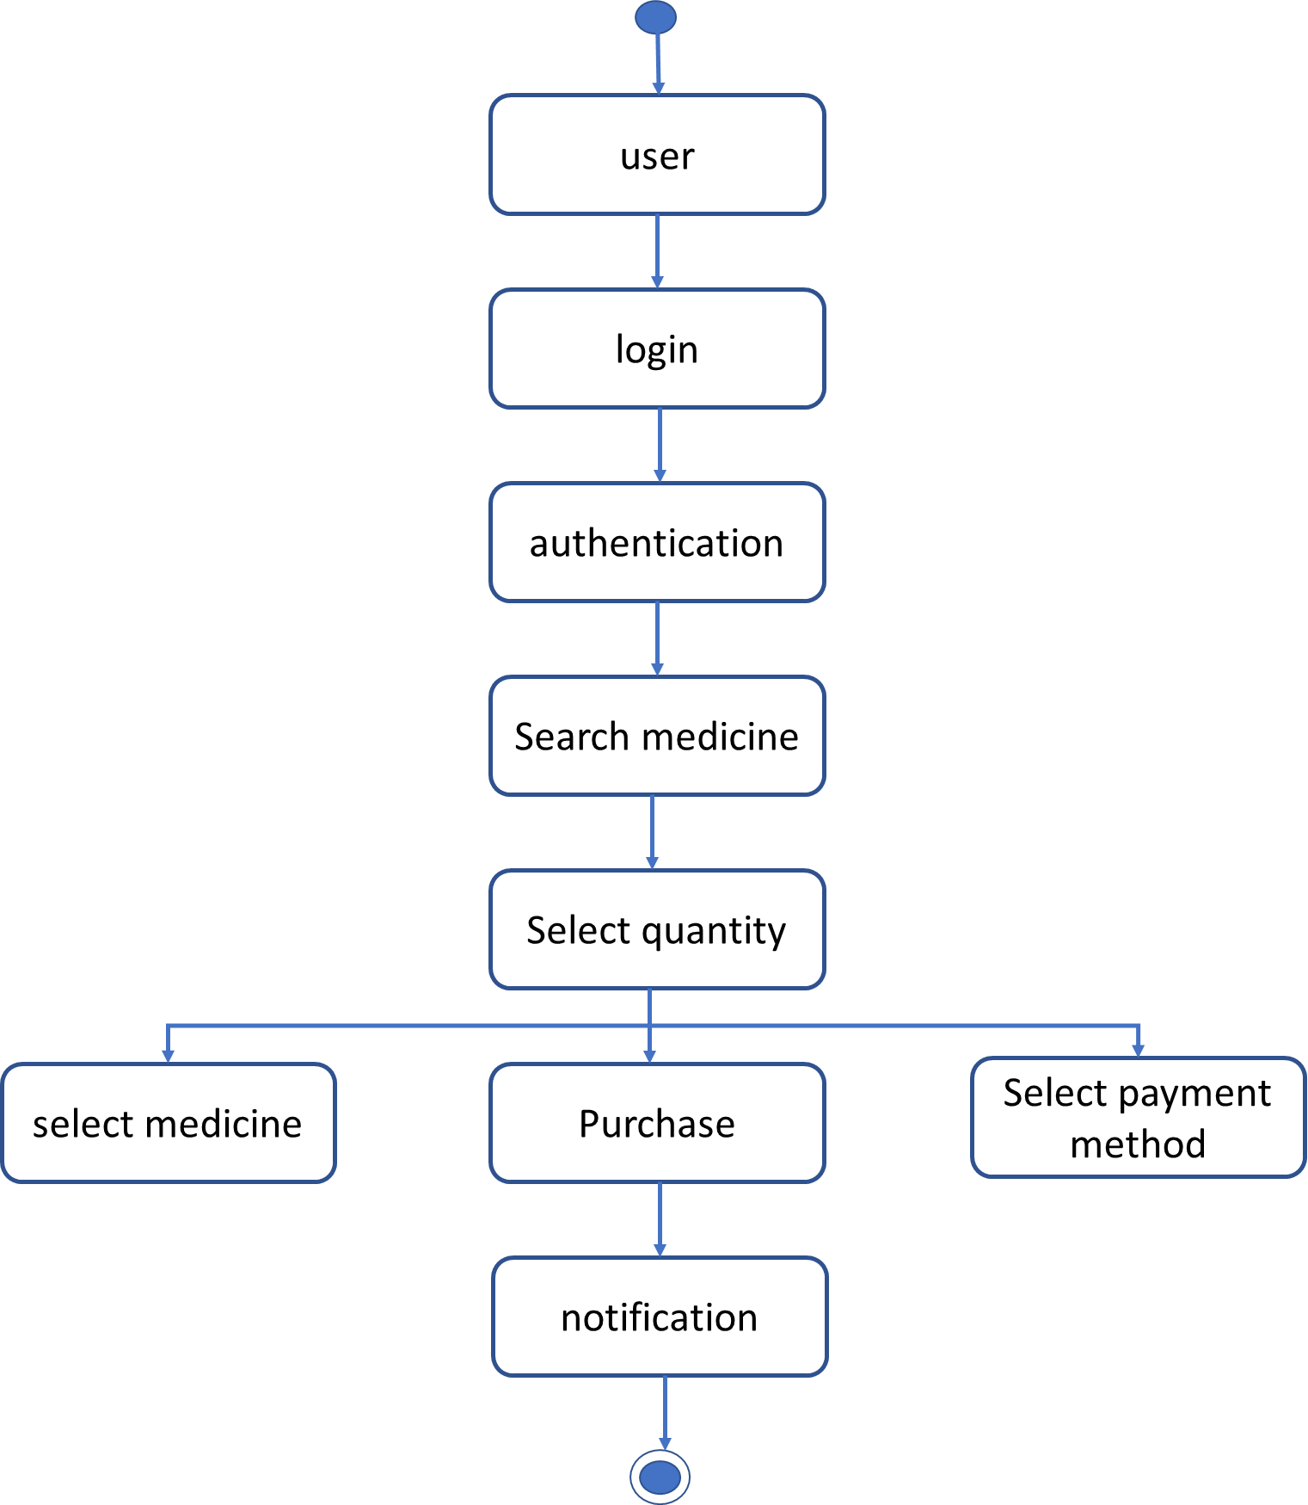

**Fig 6.5: Activity Diagram**

**6.3.2 Sequence Diagram**

The sequence diagram is used primarily to show the interactions between objects in the sequential order that those interactions occur. Developers typically think sequence diagrams were meant exclusively for them. However, an organization's business staff can find sequence diagrams useful to communicate how the business currently works by showing how various business objects interact. Sequence diagrams illustrate how objects interact with each other. They focus on message sequences, that is, how messages are sent and received between a number of objects. The main purpose of sequence diagram is to show the order of events between the parts of system that are involved in particular interaction.

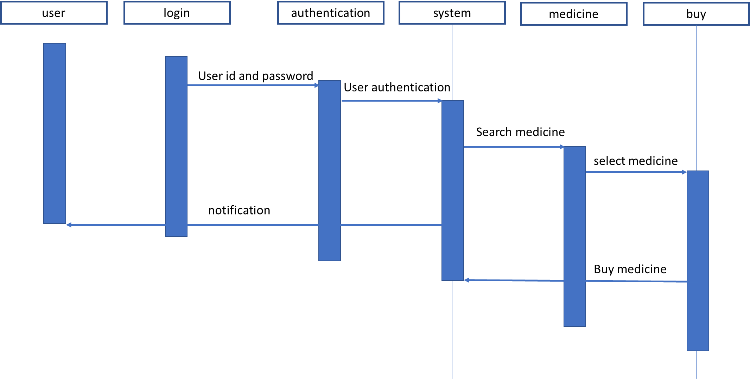

**Fig 6.6: Sequence Diagram**

**6.3.3 Use case Diagram**

Four modeling elements make up the use case diagram; these are:

* **Actors:** Actors refer to a type of users, users are people who use the system. In this case student, teacher developer are the users of the framework and application.
* **Use cases:** A use case defines behavioral features of a system. Each use case is named using a verb phrase that express a goal of the system. The name may appear inside or outside the ellipse.
* **Associations:** An association is a relationship between an actor and a use case. The relationship is represented by a line between an actor and a use case.
* **The include relationship:** It is analogous to a call between objects. One use case requires some type of behavior which is fully defined in another use case.

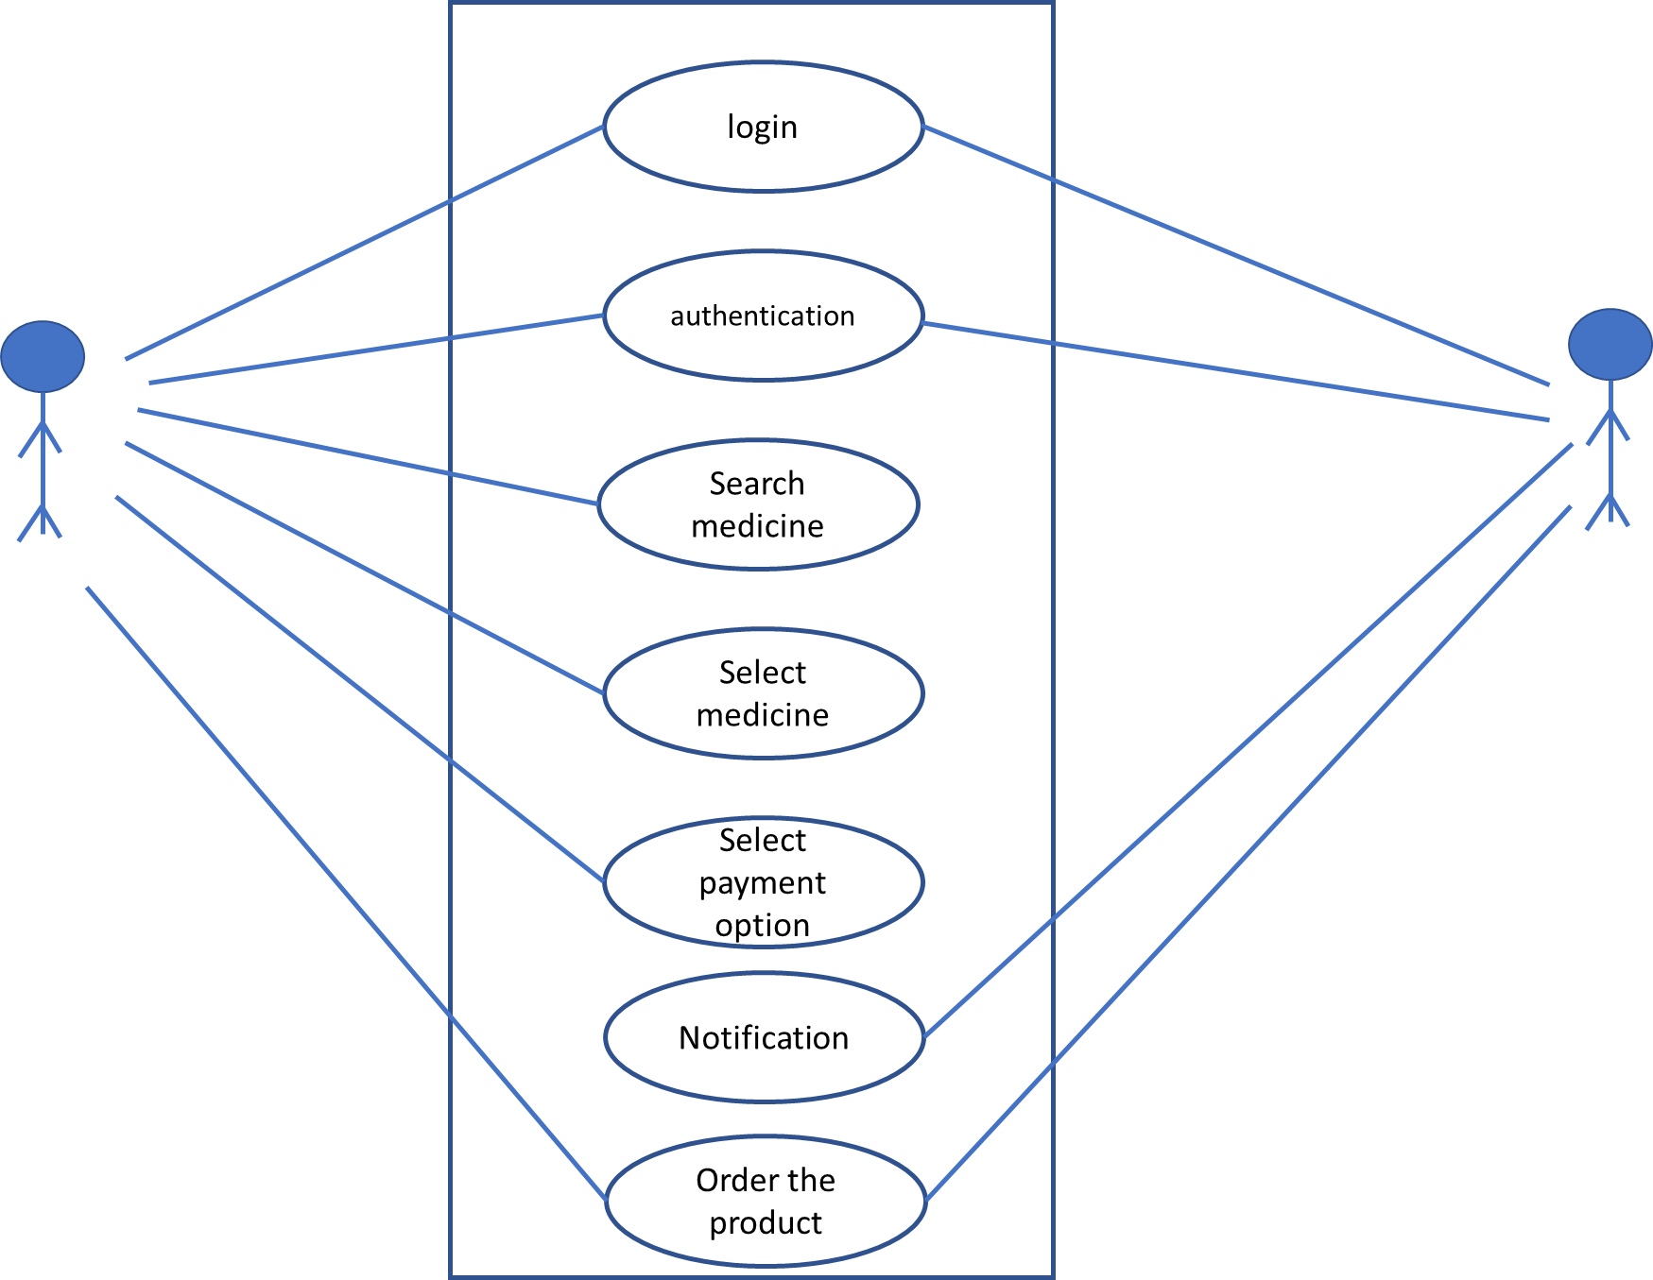

**Fig 6.7: Usecase Diagram**

**CHAPTER 7**

**PLATFORM DATABASE DESCRIPTION**

**7.1 Development Tools**

A Web application (Web app) is an application program that is stored on a remote server and delivered over the Internet through a browser interface. Web services are Web apps by definition and many, although not all, websites contain Web apps. According to Web.App Storm editor Jarel Remick, any website component that performs some function for the user qualifies as a Web app.

Web applications can be designed for a wide variety of uses and can be used by anyone; from an organization to an individual for numerous reasons. Commonly used Web applications can include webmail, online calculators, or e-commerce shops. Some Web apps can be only accessed by a specific browser; however, most are available no matter the browser.

Web applications do not need to be downloaded since they are accessed through a network. Users can access a Web application through a web browser such as Google Chrome, Mozilla Firefox or Safari. For a web app to operate, it needs a Web server, application server, and a database. Web servers manage the requests that come from a client, while the application server completes the requested task. A database can be used to store any needed information.

Web applications typically have short development cycles and can be made with small development teams. Most Web apps are written in JavaScript, HTML5, or Cascading Style Sheets (CSS). Client-side programming typically utilizes these languages, which help build an applications front-end. Server-side programming is done to create the scripts a Web app will use. Languages such as Python, Java, and Ruby are commonly used in server-side programming.

Web applications have many different uses, and with those uses, comes many potential benefits. Some common benefits of Web apps include:

* Allowing multiple users access to the same version of an application.
* Web apps don’t need to be installed.
* Web apps can be accessed through various platforms such as a desktop, laptop, or mobile.
* Can be accessed through multiple browsers.

**7.2 Database Requirement**

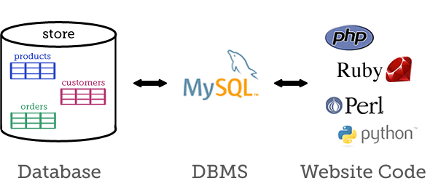

**Fig 7.1: MySQL database**

MySQL is a fast, easy-to-use RDBMS being used for many small and big businesses. MySQL is developed, marketed and supported by MySQL AB, which is a Swedish company. MySQL is becoming so popular because of many good reasons:

* MySQL is released under an open-source license. So you have nothing to pay to use it.
* MySQL is a very powerful program in its own right. It handles a large subset of the functionality of the most expensive and powerful database packages.
* MySQL uses a standard form of the well-known SQL data language.
* MySQL works on many operating systems and with many languages including PHP, PERL, C, C++, JAVA, etc.
* MySQL works very quickly and works well even with large data sets.
* MySQL is very friendly to PHP, the most appreciated language for web development.
* MySQL supports large databases, up to 50 million rows or more in a table. The default file size limit for a table is 4GB, but you can increase this (if your operating system can handle it) to a theoretical limit of 8 million terabytes (TB).
* MySQL is customizable. The open-source GPL license allows programmers to modify the MySQL software to fit their own specific environments.

**CHAPTER 8**

**SCREEN LAYOUTS**

**CHAPTER 9**

**SYSTEM TESTING**

**9.1 Introduction**

Software testing is an investigation conducted to provide stakeholders with information about the quality of the software product or service under test.

**9.1.1 Software testing**

Software testing can also provide an objective, independent view of the software to allow the business to appreciate and understand the risks of software implementation. Test techniques include the process of executing a program or application with the intent of finding software bugs (errors or other defects), and verifying that the software product is fit for use. Software testing involves the execution of a software component or system component to evaluate one or more properties of interest. In general, these properties indicate the extent to which the component or system under test:

* Meets the requirements that guided its design and development,
* Responds correctly to all kinds of inputs,
* Performs its functions within an acceptable time,
* It is sufficiently usable,
* Can be installed and run in its intended environments, and
* Achieves the general result its stakeholders desire. As the number of possible tests for even simple software components is practically infinite, all software testing uses some strategy to select tests that are feasible for the available time and resources. As a result, software testing typically (but not exclusively) attempts to execute a program or application with the intent of finding software bugs (errors or other defects). The job of testing is an iterative process as when one bug is fixed, it can illuminate other, deeper bugs, or can even create new ones.

**9.2 Black Box Testing**

This testing methodology looks at what are the available inputs for an application and what the expected outputs are that should result from each input. It is not concerned with the inner workings of the application, the process that the application undertakes to achieve a particular output or any other internal aspect of the application that may be involved in the transformation of an input into an output. Most black-box testing tools employ either coordinate based interaction with the applications graphical user interface (GUI) or image recognition. An example of a black-box system would be a search engine. You enter text that you want to search for in the search bar, press “Search” and results are returned to you. In such a case, you do not know or see the specific process that is being employed to obtain your search results, you simply see that you provide an input – a search term – and you receive an output – your search results.

**9.2.1 Black-box**

There are many advantages to black-box testing. Here are a few of the most commonly cited:

**1. Ease of use:** Because testers do not have to concern themselves with the inner workings of an application, it is easier to create test cases by simply working through the application, as would an end user.

**2. Quicker test case development:** Because testers only concern themselves with the GUI, they do not need to spend time identifying all of the internal paths that may be involved in a specific process, they need only concern themselves with the various paths through the GUI that a user may take.

**3. Simplicity:** Where large, highly complex applications or systems exist black-box testing offers a means of simplifying the testing process by focusing on valid and invalid inputs and ensuring the correct outputs are received.

But, for all of the benefits of black-box testing, many attempts to create black-box test systems resulted in several drawbacks that caused people to question the viability of the black-box approach. Some of the most commonly cited issues were:

1. **Script maintenance:** While an image-based approach to testing is useful, if the user interface is constantly changing the input may also be changing. This makes script maintenance very difficult because black-box tools are reliant on the method of input being known.
2. **Fragility:** Interacting with the GUI can also make test scripts fragile. This is because the GUI may not be rendered consistently from time to time on different platforms or machines. Unless the tool is capable of dealing with differences in GUI rendering, it is likely that test scripts will fail to execute properly on a consistent basis.
3. **Lack of introspection:** Ironically, one of the greatest criticism of black-box testing is that it isn’t more like white-box testing; it doesn’t know how to look inside an application and therefore can never fully test an application or system. The reasons cited for needing this capability are often to overcome the first two issues mentioned. The reality is quite different.

**9.3 White Box Testing**

This testing methodology looks under the covers and into the subsystem of an application. Whereas black-box testing concerns itself exclusively with the inputs and outputs of an application, white-box testing enables you to see what is happening inside the application. Whitebox testing provides a degree of sophistication that is not available with black-box testing as the tester is able to refer to and interact with the objects that comprise an application rather than only having access to the user interface. An example of a white-box system would be in-circuit testing where someone is looking at the interconnections between each component and verifying that each internal connection is working properly. Another example from a different field might be an auto-mechanic who looks at the inner-workings of a car to ensure that all of the individual parts are working correctly to ensure the car drives properly.

**9.3.1 White-box**

Like black-box testing, there are distinct advantages to white-box testing. Here are a few of the most commonly cited:

1. **Introspection:** Introspection, or the ability to look inside the application, means that testers can identify objects programmatically. This is helpful when the GUI is changing frequently or the GUI is yet unknown as it allows testing to proceed. It also can, in some situations, decrease the fragility of test scripts provided the name of an object does not change.
2. **Stability:** In reality, a by-product of introspection, white-box testing can deliver greater stability and reusability of test cases if the objects that comprise an application never change.
3. **Thoroughness:** In situations where it is essential to know that every path has been thoroughly tested, that every possible internal interaction has been examined, white-box testing is the only viable method.

As such, white-box testing offers testers the ability to be more thorough in terms of how much of an application they can test. Despite these benefits, white-box testing has its drawbacks. Some of the most commonly cited issues are:

1. **Complexity:** Being able to see every constituent part of an application means that a tester must have detailed programmatic knowledge of the application in order to work with it properly. This high-degree of complexity requires a much more highly skilled individual to develop test case.
2. **Fragility:** While introspection is supposed to overcome the issue of application changes breaking test scripts the reality is that often the names of objects change during product development or new paths through the application are added. The fact that white-box testing requires test scripts to be tightly tied to the underlying code of an application means that changes to the code will often cause white-box test scripts to break. This, then, introduces a high degree of script maintenance into the testing process.
3. **Integration:** For white-box testing to achieve the degree of introspection required it must be tightly integrated with the application being tested. This creates a few problems. To be tightly integrated with the code you must install the white-box tool on the system on which the application is running. This is okay, but where one wishes to eliminate the possibility that the testing tool is what is causing either a performance or operational problem, this becomes impossible to resolve. Another issue that arises is that of platform support. Due to the highly integrated nature of white-box testing tools many do not provide support for more than one platform, usually Windows®. Where companies have applications that run on other platforms, they either need to use a different tool or resort to manual testing.

**9.4 Test Plan**

|  |  |  |  |  |
| --- | --- | --- | --- | --- |
| **Test ID** | **Description** | **Expected Result** | **Actual Result** | **Status** |
| 001 | To check whether user successfully connected in network | User should successfully connected in network | User has successfully connected in network | PASS |
| 002 | User Login | User should Login in system | User has logged in system | PASS |
| 003 | Data store in database | System should store values in database | System has store values in database | PASS |
| 004 | Incorrect Data | If user gives wrong values ,system should show error | System has shown error | PASS |
| 005 | System performance | System should perform as per requirements | System able perform as per requirements | PASS |
| 006 | Connection to network data protocol | System should able to connect to network protocol | System is connected to network protocol | PASS |
| 007 | Delay time management | System should give quick response to | System is giving quick response to | PASS |
| 008 | Notification to user on display | System should able to give notification to user on display | System is giving notification to user on display | PASS |
| 009 | System Accuracy | System should performance features with accuracy | System able to perform features with accuracy | PASS |
| 010 | System output test System | should give all the output as per programming | System is give all the output as per programming | PASS |

**CHAPTER 10**

**FUTURE SCOPE**

In future we will purchase the domain and hosting for our project, also we will add more payments methods for online payments. We will also try the get the machine learning algorithm to help our customer to find better medicines based on there diseases. As this study is new so there will be lots of research needed in this field that will help sellers and buyers of medicines and medical products.

**CHAPTER 11**

**ADVANTAGES**

1. Time reducing
2. Less cost
3. Handling is easy
4. Marketing is possible
5. Reduce Paper Work
6. Accessible to rural area delivery

**CHAPTER 12**

**DISADVANTAGES**

1. Urgent medicines cannot be order online: As we know that, we cannot predict illness so we cannot order medicines before illness. One major disadvantage is that it takes 2-3 days in delivery.
2. Emergency medical products: Medical services are known as emergency services and generally it requires on urgent basis. So buyer can’t buy it before requirement or doctors suggest it.
3. Prescription Error: Sometimes Doctor’s handwriting is not readable. So may possible the seller read it wrong.

**CHAPTER 13**

**CONCLUSION**

E –marketing is a part of the e-commerce and has very close relationship with e commerce. This model is useful to promote improving the e- marketing method. The model is based on demand analysis of various customers as well as a new model in E-marketing to supply medicines online with 24*7 facilities. We had also kept in mind the needs of customers and their ease in ordering medicine. This will play a very important role in providing medicines at remote places where there is unavailability of medicines. There will be a detailed list of medicines available in the stock.

**REFERENCES AND BIBLIOGRAPHY**

1. Vos Bouwman and Haaker de, "Mobile Service Innovation and business models" in , Houten:Springer, 2008.
2. Eysenbach, "Medicine 2.0: Social networking collaboration participation apomediation and openness", *J Med Internet Res*, 2008, [online] Available: <http://www.jmir.org/2008/3/e22/>.
3. Giesen, "Business models for eHealth and associated best practices", 2009.
4. Heldoorn, "Gezondheid 2.0 – Toekomst en betekenis van E-Health voor de zorgconsument", *Visiondocument NPCF Utrecht*, 2008, [online] Available: <http://www.npcf.nl/?id=3163>.
5. "Healthcare 2015: win-win or lose-lose?", 2006, [online] Available: http://www-05.ibm.com/de/healthcare/downloads/healthcare_2015.pdf.